CS4620 – Summer 2014
a) | take | 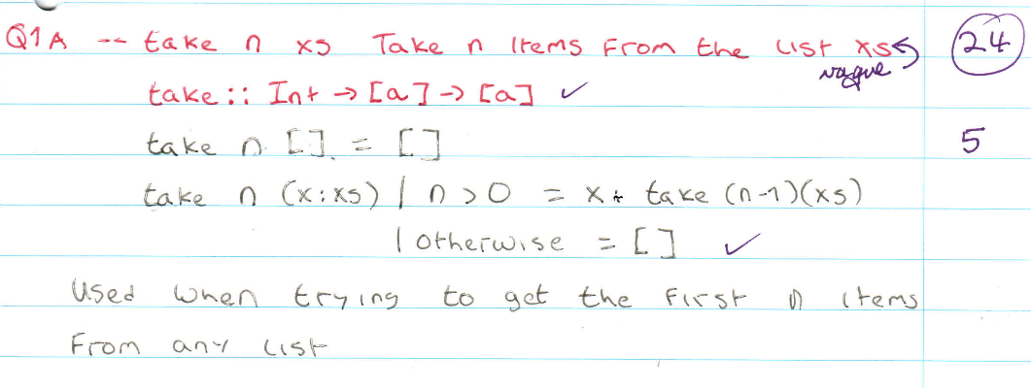  -- take n xs, take n items from the list xs  -- Used when we want to try and get rid of the first n items  take n[] = []  take n(x:xs) | n>0 = x take (n-1)(xs) | otherwise = []
b) | drop | 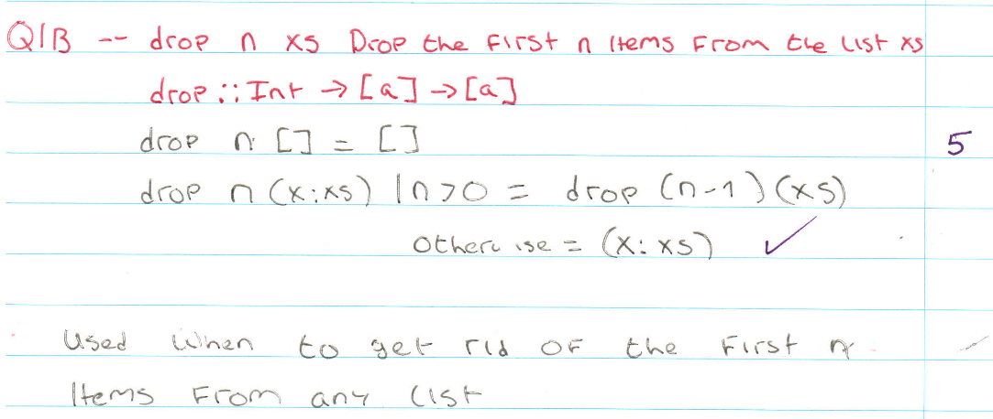  -- drop n xs drop the first n items form the list xs  -- Used when we want to get rid of the first n items from any list  drop n[] = []  drop n(x:xs) |n>0 = drop(n-1)(xs) otherwise = (x:xs)
c) | takeWhile | 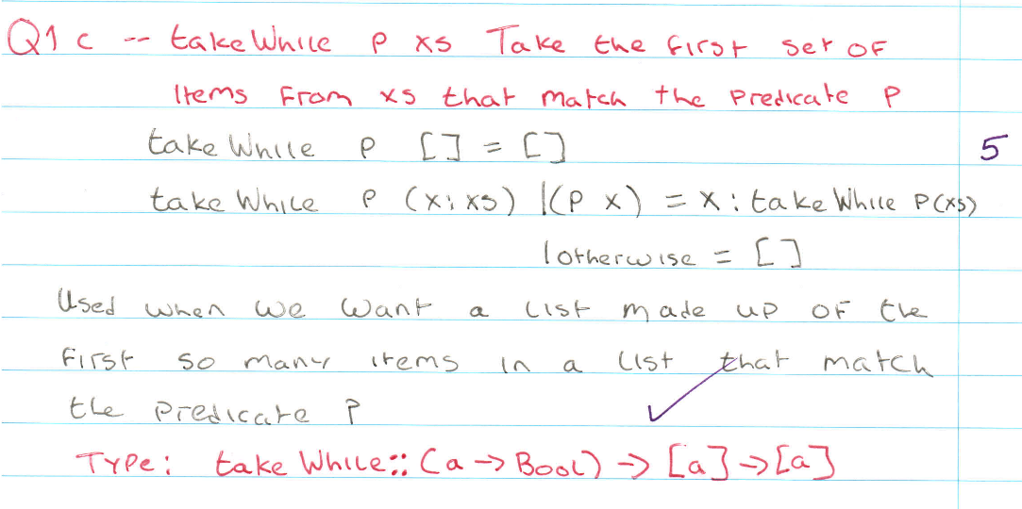  -- takeWhile p xs take the first set of items from xs that match the predicate p  -- Used when we want a list made up of the first so many items in a list that match the predicate p  takeWhile p[]= []  takeWhile p (x:xs) | (p x) = x:takeWhile p(xs) | otherwise = []
d) | dropWhile | 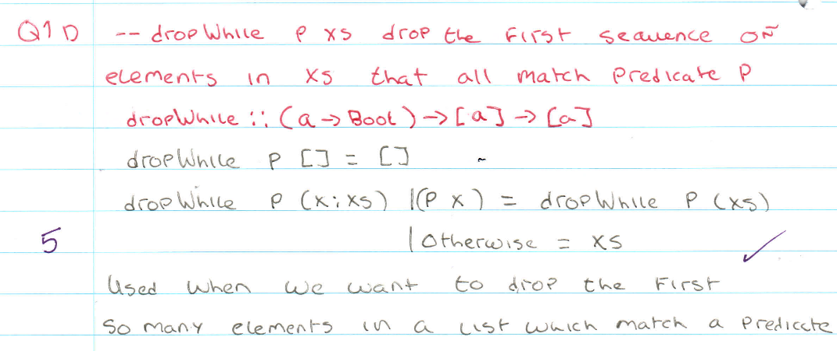  -- dropWhile xs drop the first sequence of elements in xs that all match predicate p.  -- Used when we want to drop the first so many elememts in a list which match a predicate.  dropWhile :: (a -> bool) -> [a] -> [a]  dropWhile p [] = []  dropWhile p (x:xs) | (p x) = dropWhile p (xs) |otherwise = xs
e) | zipWith | 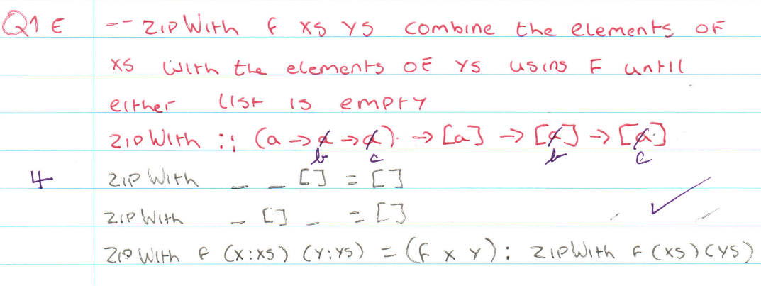  -- zipWith f x sys combine the elements of xs with the elements of ys using f until either list is empty.  zipWith :: (a -> b -> c) -> [a] -> [b] -> [c]  zipWith _ _ [] = []  zipWith _ [] _ = []  zipWith f (x:xs) (y:ys_ = (f x y) : zipWith f (xs) (ys)

Answer ???

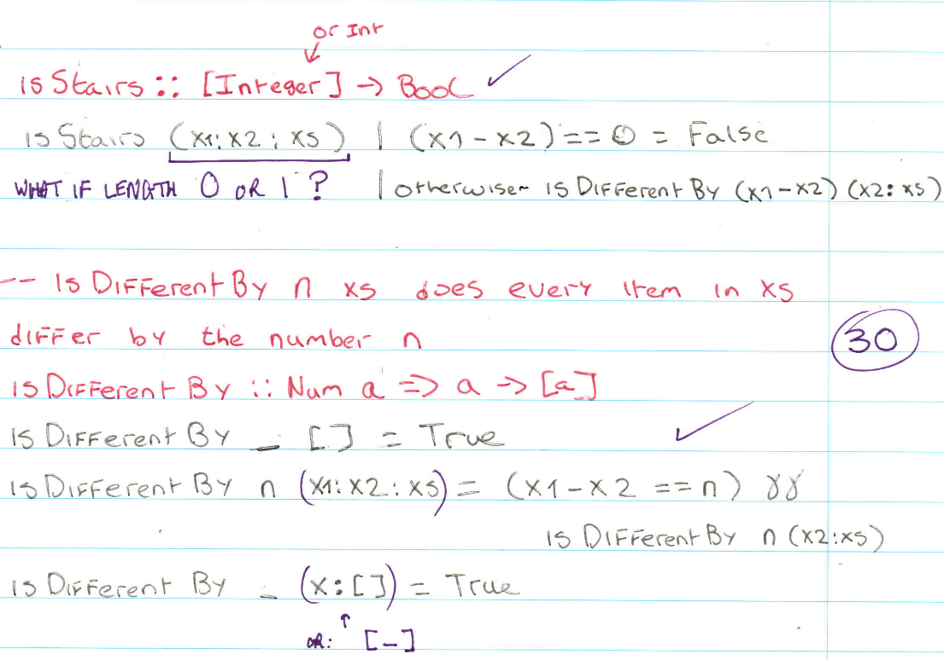

isStairs :: [Integer] -> Bool
isStairs (x1:x2:x3) | (x1 – x2) == 0 = False | otherwise isDifferentBy (x1-x2)(x2:x3)

-- isDifferentBy n xs does every item in xs differ by the number n
isDifferentBy _ [] = True
isDifferentBy n(x1:x2:x3) && isDifferentBy n(x2:x3)
isDifferentBy _(x:[_]) = True

Answer

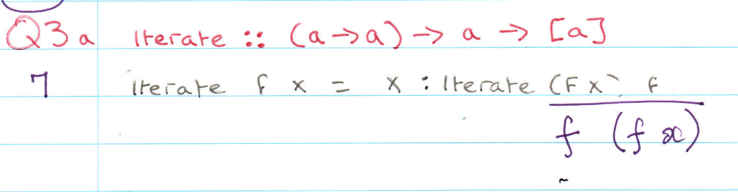

iterate :: (a -> a) -> a -> [a]
iterate f x = x : iterate f (f x)

Answer

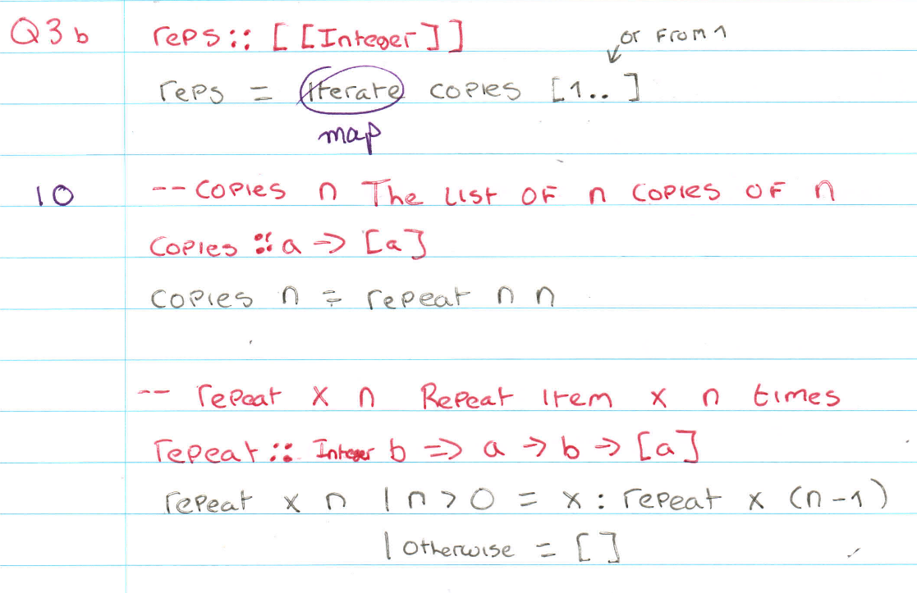

reps :: [[Integer[]
reps = map copies [1..]

-- copies n, the list of n copies of n
copies :: a -> [a]
copies n = repeat n n

-- repeat x n, repeat item x n times
repeat :: Integer b => a -> b -> [a]
repeat x n | n>0 = x:repeat x(n-1) | otherwise = []

Answer 4 Marks ???

